- First, I hang up my coat and backpack. 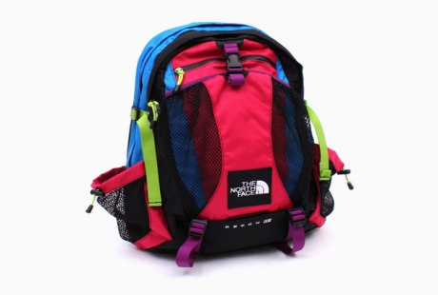
- Next, I bring my binder to my desk.
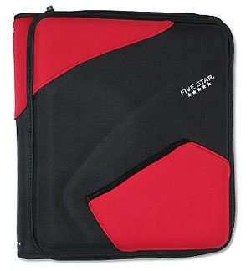
- Then, I turn in my homework to the basket on Mrs. Schmitz’s desk.
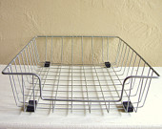
- I mark with the clip whether I will have hot or cold lunch. 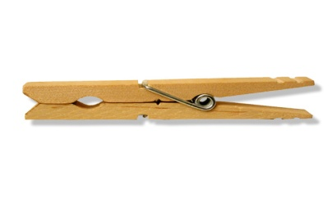

- I get the Morning Warm-up from the front table.

- I return to my desk and check to make sure my pencils are sharp. I work hard on my Morning Warm-up.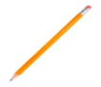

- When the bell rings I put my Morning Warm-up in my
To Do Folder. 